Financial Technology and digital innovation to modeRnise and develop cUrricula of VietnameSe and Philippines UniversiTies
Project № 610256-EPP-1-2019-1-IT-EPPKA2-CBHE-JP

5.3.
EVALUATION OF THE STUDENTS’ EXPETATIONS REGARDING MODERNIZED MASTER PROGRAMME OF BUSINESS AND FINANCE

DELIVERABLE DESCRIPTION
Deliverable number and name | 5.3. Evaluation of the students’ expectations regarding modernized master programme of business and finance
Due date | June 2022
Work Package | WP. 5.3.
Author | Sladjana Benković (UB)
Reviewers | /
Language | English
Approved by | All partners
Version | 2.

Document history
Issue date | Version | Comments
26 June 2022 | 2.

Disclaimer
This document contains the description of the TRUST project work and products. Certain parts of it might be under partners’ Intellectual Property Right (IPR) rules therefore, prior to its use please contact the consortium leader for approval.
In case you believe that this document harms in any way IPR held by you as a person or as a representative of an entity, please do notify us immediately.
The authors of this document have taken any available measure for its content to be accurate, consistent, and lawful. However, neither the project consortium as a whole nor the individual partners that implicitly or explicitly participated in the creation and publication of this document hold any sort of responsibility that might occur because of using its content.

Table of Contents
1. Introduction 5
1.1. Questionary form disseminated among students enrolled in Vietnamese and Philippines modernized master programs’ 5
TRUST PROJECT - EXPECTATION QUESTIONNAIRE FOR STUDENTS OF MASTER PROGRAMME 5
1.2. Students expectation regarding modernized master programme of business and economics 8
2. Conclusion 10
3. List of Annexes 10

List of figures
List of tables
Figure 1. Title of the figure 5
Table 1. Title of the table 6

Abstract
The goal of activity 5.3 (within work package 5) is to provide a Report on the expectations and satisfaction of students with modernized and newly accredited master's programs, during and after their realization.
As the modernized master's programs were first accredited by the competent state bodies in Vietnam and the Philippines, a report was first prepared which refers to the students' expectations from the modernized master's programs of business and finances.

Introduction
During its entire implementation, the TRUST project considers the quality of content that is the result of the project. Therefore, the goal of activity is 5.3. (within the work package 5), was aimed at monitoring the expectations and satisfaction of students with completed master's programs during the implementation of newly accredited and modernized master programs.
The University of Belgrade, as the holder of this work package, developed the questionnaire and forwarded it to the partner universities in Vietnam and the Philippines, which had the task of disseminating the questionnaire among students of modernized programs through an online Google survey.
As the modernized master's programs were first accredited by the competent state bodies in Vietnam and the Philippines, a report was first prepared which refers to the students' expectations from the modernized master's programs.

Questionary form disseminated among students enrolled in Vietnamese and Philippines modernized master programs’

TRUST PROJECT - EXPECTATION QUESTIONNAIRE FOR STUDENTS OF MASTER PROGRAMME
*compulsory
You are invited to participate in the research organized by the University of Belgrade as a partner in project Financial Technology and digital innovation to modeRnise and develop cUrricula of VietnameSe and Philippines UniversiTies – TRUST (610256-EPP-1-2019-1-IT-EPPKA2-CBHE-JP), funded by the European Commission and coordinated by the Università Degli Studi Guglielmo Marconi. The purpose of this questionnaire is to gather the expectations of students who have chosen to take modernized or newly accredited master’s degree programme upgraded or newly designed during project duration and on the base of responses to prepare the project and academic report publications.
All information gained from the study will be confidential. Only the TRUST Project team will have access to the data. The data will be securely stored on a password protected drive. The data may be used later for reports and publications, but always in an anonymous format in which the participants cannot be identified.
By completing this questionnaire and ticking the consent box below,
you confirm you agree with all of the following statement:
- I confirm that I have read and understood the above information.
- I understand that my participation is voluntary and that I am free to withdraw at any time without giving any reason by writing to benkovicsladjana@gmail.com .
- I understand that my data will be saved and analysed. The anonymised quotes may be used in publications and reports about the research. However, it will not be possible to identify me from this information. I give my permission for this.
- I agree to take part in the above study
[tick box] *

1. CONTACT INFORMATION*
First name
Last name
Email

2. PERSONAL INFORMATION
How old you are? *_____________________________
Gender: _________male __/ ___ female _______

3. EDUCATIONAL BACKGROUND
At which university and faculty did you complete your undergraduate studies? *
_________________________________________________________

How many subjects did you have in undergraduate studies in the field of financial management, banking, and financial institutions? *
________________________________________________________________________

How many subjects did you have in undergraduate studies related to information technology or e-business? *
_________________________________________________________________________

What do you know about financial technologies? *
___________________________________________________________________________

4. INFORMATION ABOUT INSTITUTION AT WHICH YOU ARE ATTENDING MODERNIZED / NEWLY ACCREDITATED MASTER PROGRAMME
Organization at which you attend master’s degree program*
- CEBU University, Philippines
- Sent Luis University, Philippines
- MAPUA University, Philippines
- University of Economics and Business, Vietnam
- College of Economics, Hue University, Vietnam
- Ho Chi Minh City Open University, Vietnam

Why did you choose this master's program? Please do explain if you had some expectations. *
___________________________________________________________________________

Do you have any special expectations when it comes to distance learning or online methodology? *
__________________________________________________________________________

Have you had the opportunity to get acquainted with the online learning methodology so far? *
__________________________________________________________________________
How would you rate experience of „distance learning" during the pandemic? *
__________________________________________________________________________

Which issues regarding “distance learning” you have detected and which improvements you suggest? *
__________________________________________________________________________

How did you make decision regarding choice of modules? *
____________________________________________________________________
What do you expect most beneficial in modules that you have elected? *
_________________________________________________________________________

How do you think the knowledge gained in master program related with financial technologies will contribute to your professional development? Please do explain. *
___________________________________________________________________________

Do you think it will be easier to you to find a job or if you work you to be promoted after completing this master programs? Please do explain*
__________________________________________________________________________

Students’ expectation regarding modernized master programme of business and finance
During the research conducted among students of Vietnamese and Philippine universities, as partner institutions - TRUST ERASMUS K2 project, to assess students' expectations from enrollment in modernized master's programs, answers were collected from 58 students, with structure of responses like on the next graph
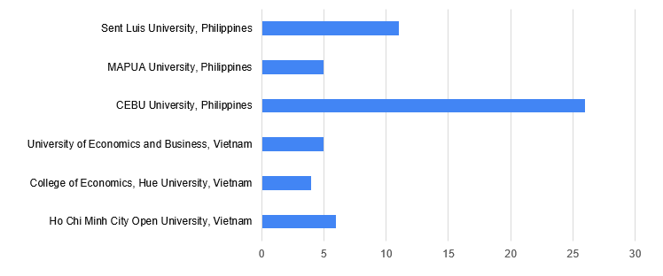
The target group of respondents who participated in the study was aged between 22 and 39 years. From the aspect of the gender structure of the research, most often the members of the female population accepted to participate in the survey with a participation in the sample of 72%.
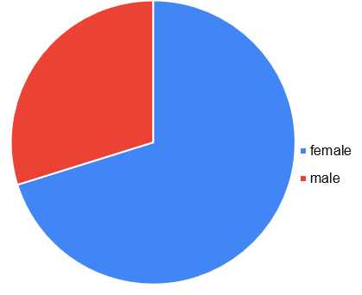
Most of the respondents have completed their studies at the university where they continue to listen to classes in a modernized master's program, and what is teachable is that they are participants in a program with financial management and accounting background. Just a few of them have a technical background from the bachelor level of studies.
This will certainly be reflected in the level of effort they will have to make to send programs, because the volatility of participants in the modernized program is visible when from the aspect of knowledge, they have gathered through listening to courses in undergraduate studies in the field of financial management, banking, and financial institutions. The largest number of respondents listened to at least 3-5 subjects, and there are also students who listened to as many as 29 subjects that follow the mentioned subjects.
At the same time when the respondents were supposed to decide on the subjects, they studied in undergraduate studies related to information technology or e-business, most of the respondents did not agree on this question or the answer was limited to 2-3 subjects. Only two respondents answered that they had listened to 5-6 subjects.
The answers of the respondents regarding their knowledge related to Financial Technologies are interesting. Most often, the answers went in the direction of .... technology used to enhance finance activities…., or……financial technologies, also known as Fintech, refer to improvements or innovations of technologies to create a more efficient way of processing financial transactions and services ... which indicates that participants in modernized programs have a clear understanding of what finance is and where they have made their greatest contribution. Only a few respondents were negative about this issue and indicated that they do not know what financial technologies are.
When it comes to their expectations from the program, the answers of the participants are also interesting. Most of the answers were related to the improvement of knowledge in the field of modern business, while there are also answers that are quite personal and indicate that the expectations of the participants are focused on personal growth and development, as well as progress in the career.
Program participants recognize the benefits of distance learning, in most cases. They are also interested in their answers, which they see as an advantage, flexibility, and the possibility of harmonizing learning with other obligations, as well as maximizing the use of technological solutions that require less theory and much more practical knowledge that is well and carefully prepared by lecturers.
Of course, there were also agreements, which indicate that the participants lack personal contact with the lecturers and the possibility of a more interactive exchange of thoughts during the monitoring of classes.
The largest number of participants answered positively to the question of whether they have had the opportunity to get acquainted with the methodology of distance learning. Certainly, the COVID 19 pandemic that affected the whole world contributed to that. Additionally, when students were asked to evaluate their distance learning experiences, over 75% of the respondents were extremely positive about this way of learning. On a scale of 1-10, those grades range over 7. The main reason students state is the possibility of saving time and money. They especially point out the possibility of harmonizing the learning period with daily obligations, especially for the participants of the program who work.
The biggest challenge when it comes to distance learning, students of the program, singled out the stability of the Internet connection and short deadlines for the realization of tasks.
Participants in the newly accredited programs point out that they chose these modules because their professors pointed them out, or that they recognized these modules as a great opportunity to continue their professional career. Therefore, should be highlighted that students recognized as the most beneficial in modules, that they have chosen the opportunity to progress, to learn more about financial technologies that change financial business in many ways and bring innovations. They increase the number of transactions and contribute to non-cash payments.
When asked how the participants think that the knowledge gained in the master's program related to financial technologies will contribute to their professional development, they could see several answers, among which should be singled out… It will help them to run, improve or to develop own business in the future with the use of Fintech…. or ….to make their work easy and improve their knowledge on financial technology.
And it should be noted that all respondents to the survey were positive in terms of their expectations regarding easier finding a job or the possibility of advancement in their current job.

Conclusion
At the end of the research, it should be concluded that all respondents had positive expectations from the newly accredited master's programs. Also, their expectations are focused on both professional and personal progress. They are aware of the benefits of distance learning, and from the aspect of flexibility in reconciling their private and professional obligations, but they are also aware that they will have to provide better technical conditions for monitoring this type of teaching, and that they will have to work harder. Because the obligation seen through tests and quizzes is more, not less, in distance learning.
Most of the research participants have positive experiences when it comes to distance learning and are aware of the impact of information technology and innovation on all spheres of life, including the field of financial business and business. Accordingly, their expectations are directed towards the fact that they will be more successful in the modern financial and business environment after completing the modernized master's program.

List of Annexes
Annex I – Evidence based table

